NAME - ONKAR PRATAP TORANE
PROJECT ON PYTHON
Que - Write a program in Python to generate MD5 of string data.
Ans -
import hashlib
print(hashlib.md5('Baby Taehyung You Tube Channel'.encode('UTF-8')).hexdigest())

Input Screenshot
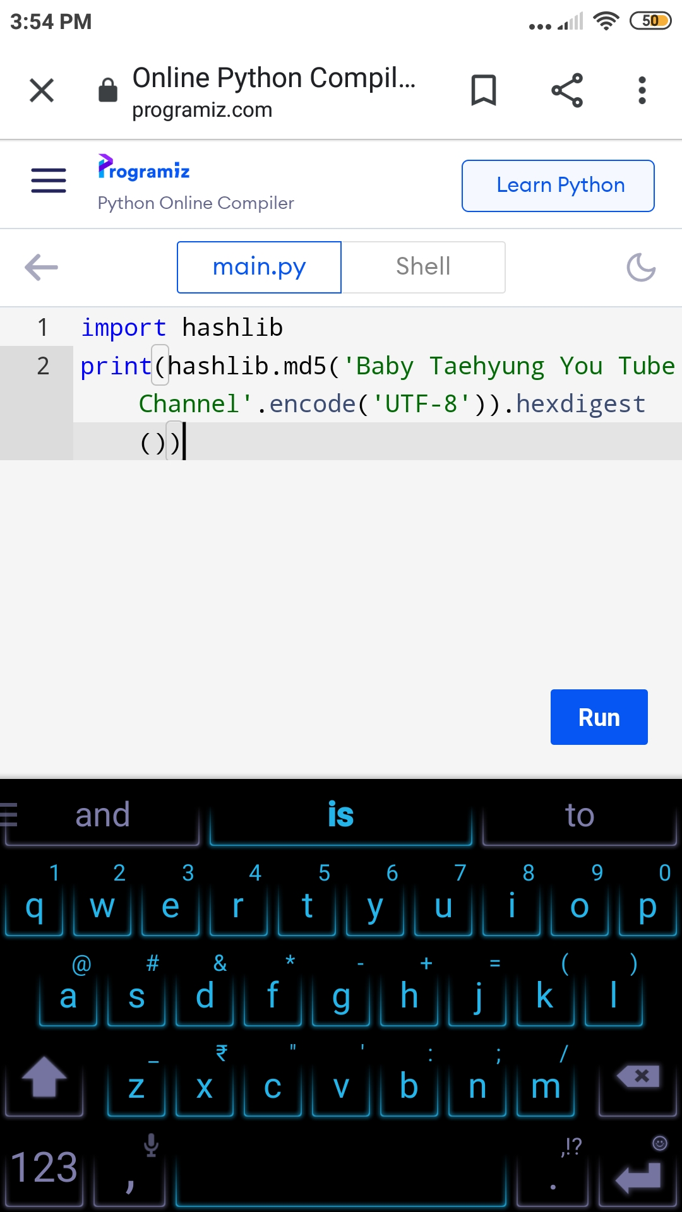
Output Screenshot:-
